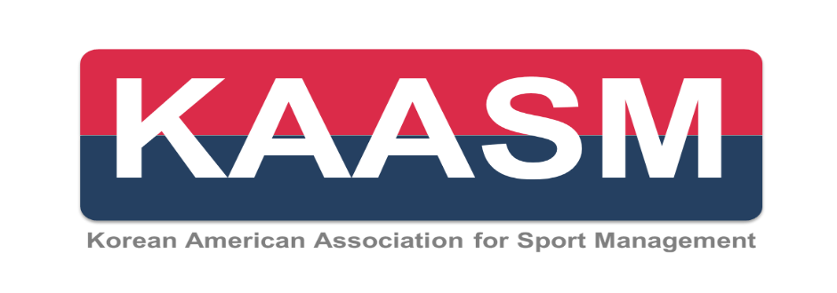

**Scholarship Application Form**

**Personal Information**

|  |  |
| --- | --- |
| First Name: | Last Name: |
| School and Program currently enrolled: | |
| Years in the Program: | |
| Email Address: | |
| Membership Status: I am currently a student member of KAASM. Yes ( ) No ( )  *You must renew or register your student membership for 2024. Annual membership runs from January 1 to December 31.* | |
| Your Plan to Attend 2024 NASSM Conference:  ( ) My research has been accepted for the 2024 NASSM Conference presentation and I RSVP’d.  ( ) My research work has been accepted for the 2024 NASSM Conference presentation but I am not sure   if I will attend the conference yet.  ( ) My research work has been waitlisted for the 2024 NASSM Conference presentation. | |

**Scholarships**

|  |
| --- |
| **This is an application for :**   1. Korean American Association for Sport Management Scholarship (____) 2. Lee Jeoung Hak Award (____) 3. Kim Yu Kyoum Travel Grant (____)   ***Studentswho apply for multiple scholarships should submit an essay for each scholarship. Please review the specific scholarship guidelines for additional requirements and eligibility details in Scholarship Announcement. |

**Publications**

|  |  |  |
| --- | --- | --- |
| **Please list your scholarly publications in APA format**. | | |
| **References** | | |
|  | **1** | **2** |
| 1. Name |  |  |
| 1. Position |  |  |
| 1. Relationship to you |  |  |
| 1. Contact information | Email:  Phone: | Email:  Phone: |